Density dependence- Improved model
Creating density dependent model
- What rates affected? Recruitment = fertility (cubs per female, no. females reproducing), cub survival
- Functional forms of effects? What mating function, Ricker model
- Parameter values?

Need to know- litter size per female? How many females per male? Both change with density
Carrying capacity- envir correlates (temporal variability), habitat quality.
Density dependence on vital rates: Bright ross 2020 -Theta given (0.006) strong density dependent effects. Macdonald 2013- effect on recruitment, not survival
Changes to sex ratio, number of cubs produced. Larger cub cohorts= female skew- ignore

higher female densities led to fewer females commencing reproduction in their first viable year(2.4% ±1.3 SE of females producing cubs at age 2 at the highest Ni; 17.1% ± 8.7% at the lowest). Closer to SR parity, females were more likely to produce their first litter of cubs at ages 4 or 5(as many as 36.6% ± 10.3 SE at age 4 and 37.8% ±

Mating functions
Determine prob finding opposite sex to mate. Female access to reproduction, different from fecundity (average offspring produced given pop size)- litter size per mated female (U) * broods
Multiplier for successful pairs- not all females reproduce, depends on density
Density dependence on no pairs or average litter size- could get different b values.
Justifying my choice- harmonic mean can overestimate reproducing individuals- dangerous when examining extinction. (J. Cachelou et al. 2024). Harmonic mean unsuitable in birth pulse, min or mod harmonic better (Bessa-Gomes, Legendre et al. 2010)

Minimum mating function
$$c=min⁡(f,hm)$$
If f=50, m=10, h=4, then mated pairs= 40 (hm<f)
This assumes all members of least abundant sex mate
More robust if sex ratio becomes uneven, can be successfully applied to polygynous systems, doesn’t violate requirements of model

Harmonic mean mating function
$$c=\frac{2fhm}{f+hm}$$
Harmonic birth function= $B(N_{f}, N_{m})=\frac{\left(2KN_{f}N_{m}\right)}{N_{m}+{(N}_{f}h^{-1})}$
Rearranged, $f=\frac{KN_{m}}{N_{m}+{(N}_{f}h^{-1})}$ K= litter size= 2.4 (source) h= Harem size= 4 (source)
Where f= offspring per adult female given n females and males

Modified harmonic mean function
If female abundance less than pairs formed by harmonic mean, use nf
$$c=min⁡(f,\frac{2fhm}{f+hm})$$
BUT doesn’t work when f>m, male mating >1.

Application
Macdonald 2013 – demographic buffering hypothesis = slow living adult mammals buffer their survival against fluctuations in external and internal pressures, including density, but then experience fluctuations in reproductive effort (Gaillardet al.1998, 2000)
g(N)= per capita growth rate
f(N)= Ng(N) is growth rate for given pop size
Ricker function= $f(N)=Ne$^{-bN}
Ricker model most appropriate- Macdonald, Newman, 2009. An analysis of Eurasian badger (Meles meles) population dynamics: implications for regulatory mechanisms. Journal of Mammalogy, 90(6), pp.1392-1403.

Parameter estimation
B approaches 1 at carrying capacity
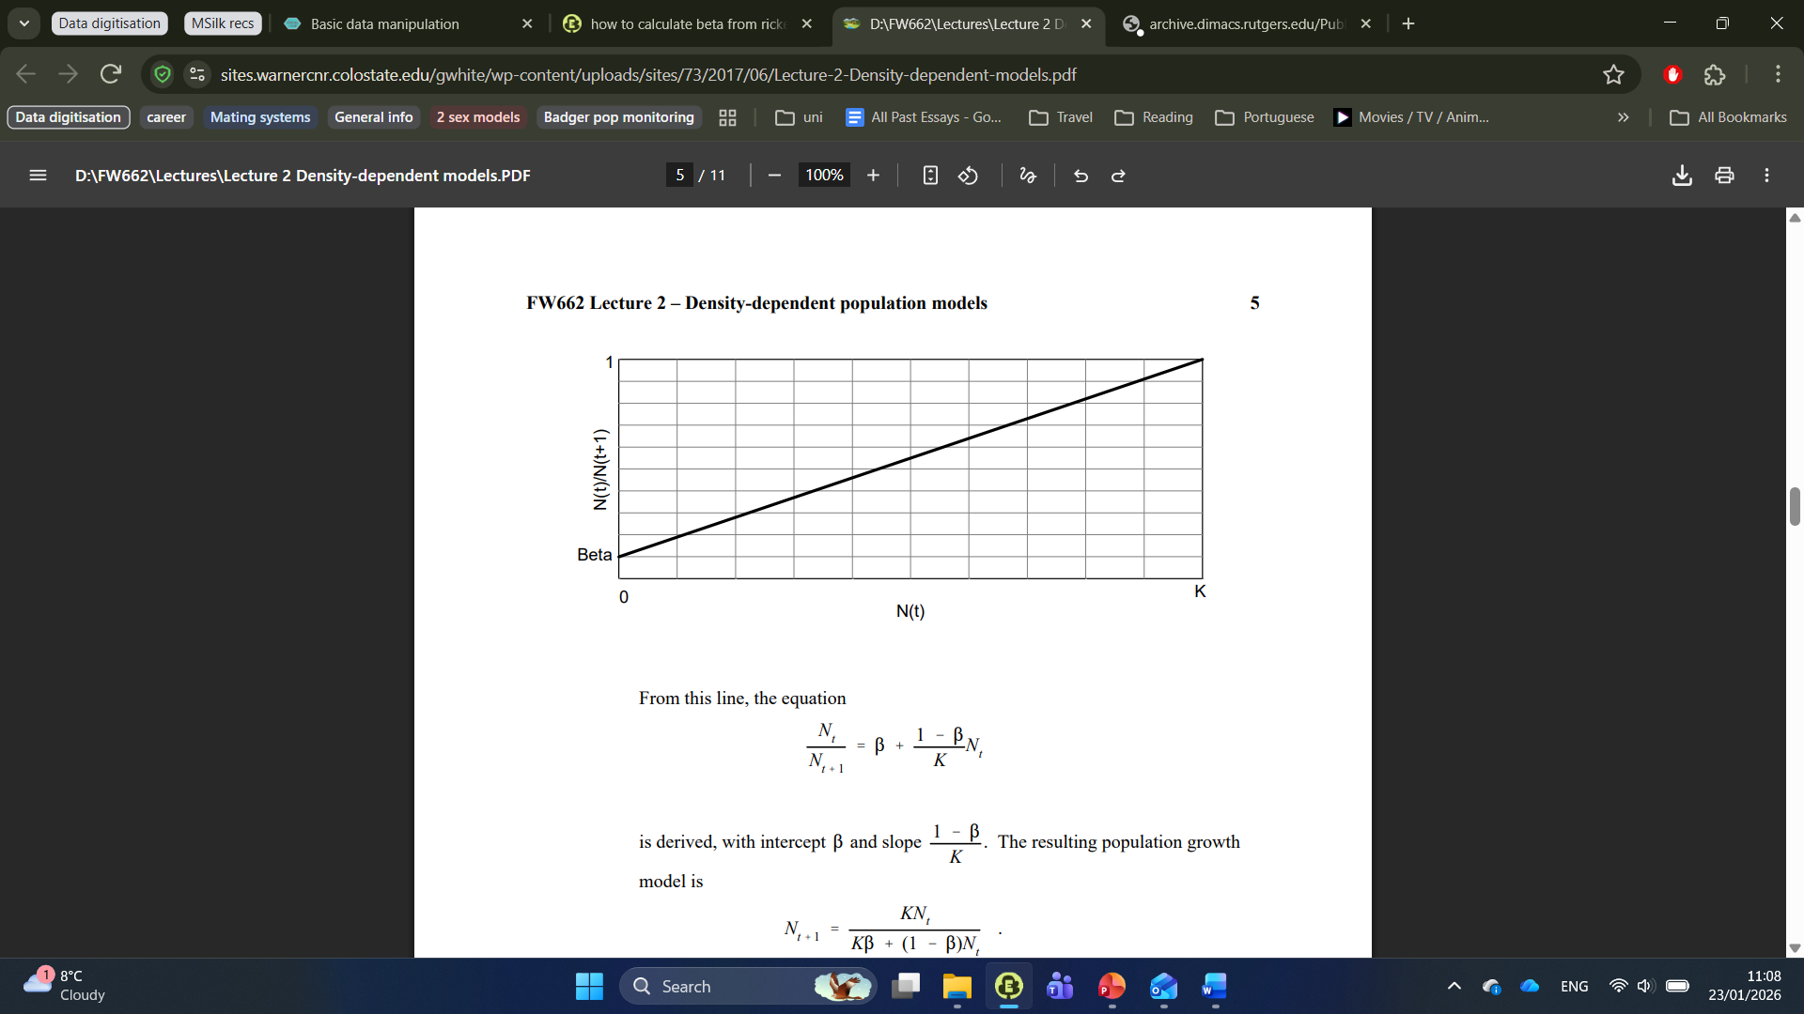
intercept β and slope $\frac{1-β}{K}$

mcdonald – correlating pop size and recruitment

Comparison data
High density and low density population demographics,
Reproductive parameters = birth rate of female cubs per adult female (not yearling females). Doubled for cubs per adult female.
Proportion of each stage class for years. Data from 3 years (1995-1997).
Create linear (?) model between density and cub production per female, use to determine strength of density dependence. Mating function AND Ricker for fertility matrix?
cub death per day- can we calculate survival function?
Tuyttens, F.A.M., Macdonald, D.W., Rogers, L.M., Cheeseman, C.L., and Roddam, A.W., 2000. Comparative study on the consequences of culling badgers (Meles meles) on biometrics, population dynamics and movement. Journal of Animal Ecology, 69 (4), 567–580.

Figure S2. Regression slopes describing the relationship between recruitment (R) and covariate effects (a); density _{t-1} (N). The posterior mean is displayed alongside their 95% credible intervals on a log scale. (b-d) Followed by their effects on recruitment rates predicted from an IPM.

Table S2. The mean and 95% CRI of the posterior distribution of each regression R-squared.
 | Posterior mean R-squared | 95% CRI
Female Survival~Density | 0.02 | (0.002, 0.22)
Male Survival~Density | 0.004 | (0.0001, 0.10)
Recruitment~Disease | 0.02 | (0.001, 0.46)
Recruitment~Density | 0.88 | (0.17, 0.95)

Application in code
Separating Fmat (fertility matrix) and Umat (survival matrix) to apply density dependence.
Fmat with mating function
Umat base= values from Macdonald, D.W. and Newman, C., 2002. Population dynamics of badgers (Meles meles) in Oxfordshire, U.K.: numbers, density and cohort life histories, and a possible role of climate change in population growth. Journal of Zoology, 256 (1), 121–138.
Amat= Umat + Fmat
Each year, calculate f using constant k and h (defined in params), variable Nf and Nm (calculated in loop)
Each year, apply ricker model to cub survival and reproductive rates (recruitment). Using constant b (params) and variable N (calculated in loop).
N values include adults and yearlings, not cubs.

Bessa-Gomes, C., S. Legendre and J. Clobert (2010). "Discrete two-sex models of population dynamics: on modelling the mating function." Acta Oecologica 36(5): 439-445.

